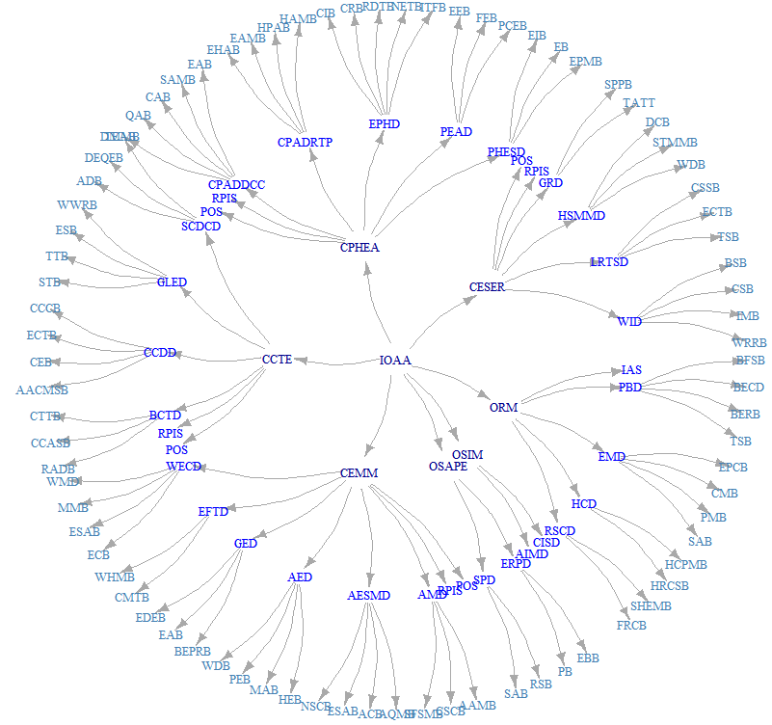

Figure : EPA-ORD Proposed Reorganization Structure

Graph Characterization: 126 Nodes, 125 Edges

Directed Rooted tree “Arborescence”, Rooted at IOAA

Depth 0 has 1 Node - “IOAA”

Depth 1 has 7 Nodes - These are the offices/centers

Depth 2 has 36 Nodes - These are the divisions

Depth 3 has 82 Nodes (leaves) - These are the branches

Distance Characterization:

The distances range between 1 and 6 among managers. With branch chiefs in different centers occupying the furthest distance at 6. All managers are 1 away from their supervisor and from their supervisees.

The goal of this exercise is to minimize the average distance in the network by adding edges between groups of nodes through a grouping exercise. In this case, we will assume that we will divide the 126 managers into 14 groups of 9 (or 9 groups of 14?)

Initial Thoughts:

* Most connectivity will be gained by adding edges between branch chiefs in different offices/centers. This reduces the distance between those individuals from 6 to 1, Division directors then get reduced from 5 to 2 and office/center directors from 4 to 3.
* Does this, however, have the largest impact on the most actors? For example, a single connection among division directors decreases the distance between all of the branch chiefs to 3.

Average distance (undirected) is: 4.73

